CSA05-DATABASE MANAGEMENT SYSTEMS
LAB OBSERVATION
EXPERIMENT:03
AIM:
To perform Data Manipulation Language (DML) Commands such as INSERT, SELECT in the table.
QUESTION:
1. Populate all the five tables with your own data.
SQL QUERIES:
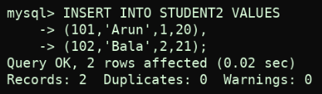
OUTPUT:
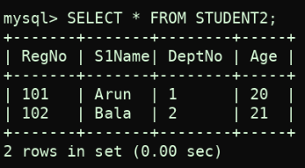

2. View all the records from the five tables.
OUTPUT
: 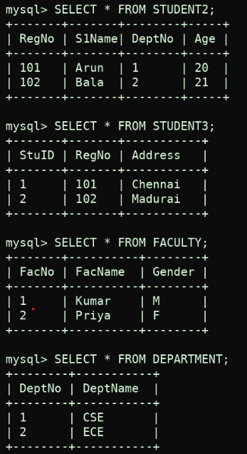

RESULT:
Data Manipulation Language (DML) Commands such as INSERT, SELECT are performed in the five tables.

